**Leaders | After the downturn**

**社论 | 经济衰退发生后**

(英文部分选自经济学人20220729社论版块)

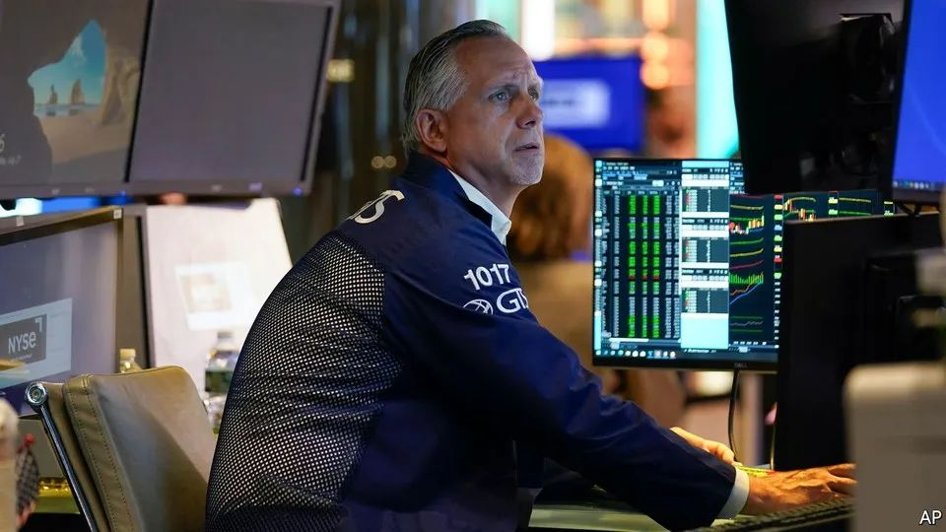

Leaders | After the downturn

社论 | 经济衰退发生后

**The silver linings of a recession**

**经济衰退的积极一面**

**Lower inflation and greener energy are worth the price of a short downturn**

**短期经济衰退换来更低的通货膨胀和更环保的能源，值了！**

Predicting a global recession usually means **standing out from** **the crowd**. Today it is those saying the world economy will avoid a downturn who are **sticking their necks out**. America’s Federal Reserveis **leading a broad charge** to tighten monetary policy, and has raised interest rates by 2¼ percentage points since March. It is expected to impose another point of tightening by December. Europe is short of natural gas because of falling supplies from Russia.

一般来说，预测全球经济衰退的人算是独树一帜。如今正好相反，谁要说世界经济不会衰退，谁才是不忌众议。美联储正带头全面收紧货币政策，自今年3月以来，已将利率上调2.25%。预计美联储将在12月之前再加息100个基点。由于俄罗斯天然气供应减少，欧洲天然气正处于短缺状态。

So gloomy is the mood that many investors are asking whether a recession has already arrived. It is a hard question to answer. The pandemic has **played havoc with** economic indicators. Inflation has caused consumer confidence to plunge, but when asked about their personal finances rather than the whole economy, people are much cheerier. America’s disappointing GDP figures do not **tally with** other measures of output or employers’ growing payrolls. Manufacturing surveys register their weakest results since the early days of the pandemic, but that may be because consumers are still rebalancing their spending after the worst phase of the pandemic (there is less buying of home-gym equipment, but more queuing in airports). **Even China’s slowdown could help Europe narrowly**, by reducing global demand for liquefied natural gas.

形势如此悲观，以至于许多投资者都在疑惑，经济衰退是否已经到来？这是个很难回答的问题。疫情令各项经济指标失灵。通货膨胀极大削弱了消费者信心，但当人们被问及个人财务状况而非整体经济形势时，他们要相对乐观得多。美国国内生产总值的数据令人失望，但这与其他产出指标不符，与火热的就业市场也不符。根据调查，制造业的相关数据是自疫情爆发初期以来最差的，但这可能是因为疫情顶峰过后，消费者仍处于重新调整消费结构的阶段（家庭健身设施的消费减少了，但在机场排队的人增多了）。**就连中国经济增长放缓也可能对欧洲（的天然气问题）略有帮助**，因为这意味着液化天然气的全球总需求降低了。

注释：

If one thing **plays havoc with** another or **wreaks havoc on** it, it prevents it from continuing or functioning as normal, or damages it.

Regardless of whether economies are already shrinking, it is hard to see how they can avoid a recession over the next year as monetary tightening bites and Europe **heads into** a bleak winter. **The silver lining is that** both higher interest rates and the energy shock will bring gains that should strengthen the world economy **in the long run**.

无论各经济体是否已在萎缩，在货币紧缩政策产生不良影响、欧洲**进入**寒冬的情况下，这些经济体在未来一年似乎怎样都难以避免经济衰退。**尚存的一线希望是**，利率上升和能源遭受冲击都将带来益处，**长期来看**应有利于世界经济发展。

Some recessions **feed on** themselves as indebted households cut their spending or defaults cascade through a fragile financial system. **With a few exceptions**, **such as Canada’s frothy housing market**, **today’s big economies suffer from few such vulnerabilities**. In fact, households and companies look strong.

家庭因负债而削减支出，拖欠债务情况在脆弱的金融体系中愈演愈烈，这让一些经济衰退形成了恶性循环。**然而除了少数个例**，**如存在房地产市场泡沫的加拿大**，**如今的经济大国几乎未受此类不良情况影响**。事实上，这些国家中家庭和企业的财务状况似乎都相当乐观。

**The bank balances of the poorest American households are around 70% fatter than they were in 2019**. **Even the threat of an emerging-market financial crisis—the usual worry when the Fed raises rates—is not what it once was**. That is in part because of a switch towards debts denominated in local currencies rather than dollars.

**相比2019年，美国最贫穷家庭的银行账户余额增加了约70%**。**即使新兴市场有发生金融危机的潜在风险——这也是美联储加息时常有的忧虑——这样的潜在风险也不复从前了**。这一定程度上是因为，一些国家已从美元计价债务转向本币计价债务。

**The main global economic fault line is inflation**. **Thankfully, it is still short in the tooth**. The last time the Fed tightened monetary policy so dramatically, in the early 1980s, prices had more than doubled over the previous decade. Today the figure is just 29%, because inflation only **took off** last year. Though America’s economy has badly overheated, long-term inflation expectations remain modest. The best historical analogy is probably not the prolonged battle with stagflation of the 1970s but the burst in consumer prices that followed the mass disruption of the Second World War. The downturn that brought that inflation to an end was shallow and left few scars. A mild recession should **squeeze** price rises **out of** the economy this time, too. Already, markets are betting that American prices will rise by about 3.8% over the next year, less than half the current inflation rate.

**全球经济容易出问题的地方在于通货膨胀。值得庆幸的是，通货膨胀的问题目前尚在萌芽阶段**。上一次美联储如此大幅收紧货币政策是在上世纪80年代初，当时的物价在之前的十年间上涨了一倍多。如今，这一指标仅为29%，这是因为通货膨胀去年才开始突然加剧。尽管美国经济严重过热，但出现长期通胀的可能性不大。纵观历史，与现状最为相似的，可能不是上世纪70年代与滞胀的长期斗争，而是在二战造成大规模混乱之后消费价格的飙升。二战后的经济衰退结束了此前的通货膨胀，而衰退本身并不严重，也没有带来什么深重影响。这一次，一场轻微的经济衰退也会消除经济中的物价上涨。目前，市场已预测美国的物价在未来一年将上涨3.8%左右，还不到目前通胀率的一半。

Elsewhere the main impetus for inflation is soaring global food and energy prices and disrupted supply chains, which are raising the price of imported goods. **Some shortages are already easing**. Wheat prices are down by nearly 40% from their recent peak in May. Oil prices have also been falling lately. Supply chains are recovering. Unfortunately, Europe’s gas shortage is getting worse. **Though governments are doing their best to shield consumers from the consequences**, if rationing becomes necessary, industrial production and hence GDP will fall, perhaps steeply in exposed economies like Germany. Even as output shrinks, inflation will rise further.

在其他国家，加剧通货膨胀的两大元凶则是全球粮食与能源价格飙升以及供应链受扰，这些因素抬高了进口商品价格。**部分供应短缺现象已有所缓解**。近期，小麦价格自5月见顶以来，已下跌近40%；石油价格持续下降；供应链也正在恢复。遗憾的是，欧洲天然气短缺情况越来越严重。**尽管欧洲各国政府竭力保护消费者免受波及**，但如果天然气到了不得不定量配给的地步，那么工业生产将会萎缩，国内生产总值也将随之下跌，对于德国等易受影响的经济体而言情况可能更加严重。而即使产量下降，通胀也会进一步加剧。

Yet in the same way that a downturn should purge the American economy of its inflation problem, so Europe could **emerge from** recession having overcome its complacency about the supply of energy. Policymakers have belatedly realised that a carefully managed shift to clean energy also eases their dependence on regimes.

经济下行固然不是好事，但却有助于美国应对目前的通胀难题；同样地，如果欧洲能就此解决能源供应的顽疾（他们似乎觉得自己做得还不错），也算是没有白白吃经济衰退的苦。政策制定者们后知后觉地意识到，如能妥善转用清洁能源，便能减少对那些化石能源出口国的依赖。

Around the world, investment in renewable energy is surging and governments that were previously sceptical about nuclear power—an essential part of a low-carbon energy grid—are reconsidering their opposition to it. Even Japan, which suffered the Fukushima disaster in 2011, is hoping to restart more nuclear reactors. If the world emerges from the coming downturn with inflation under control and on the path to greener, more secure energy supplies, the pain will not have been for nothing.

全球对可再生能源的投资正在激增。先前对核能持怀疑态度的多国政府，也开始重新打量这种重要的低碳能源。就连2011年遭受福岛核泄漏灾难的日本，也希望重启更多核反应堆。如果全世界在度过即将来临的经济衰退之后，通货膨胀得到控制，各国也得以走上更加绿色安全的能源供应之路，那么经济阵痛也是不无好处的。